SK8R

* A 2D game where you are skating around a pixely style neon orange landscape, dodging obstacles and disintegrating bystanders you run into with your laser skateboard.
* You would ramp off things to do tricks, and could take multiple routes such as in the subway or through a building.

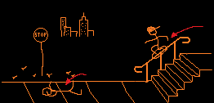

Helpful Dungeon

* A twin stick style game where you control the characters movement with one stick and the environment with the other.
* It would be 3D isometric dungeon crawler, where one stick would highlight a piece of the environment and move it whilst the other navigates the dungeon.
* You could enter a room with an enemy and pull the wall off as a physics object, crushing it between 2 walls.

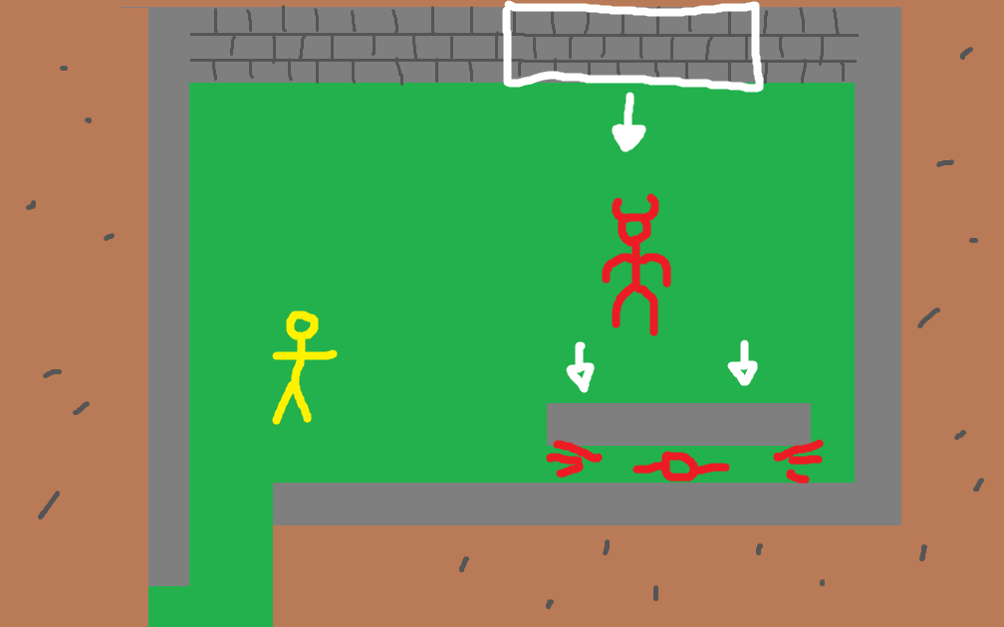

Not Frogger

* A 3D platforming game where you play as a frog.
* Must traverse the levels by jumping, crawling on walls, and using your tongue to stick and swing from things.
* Traverse through different levels like jungle, river, city.
* The tongue swinging would be physics-based and you could throw yourself with momentum.

Cook Champ

* A simple cooking game where it’s a world championship
* You pick your country and have a special dish, which would be the national food such as Italy and pizza
* You compete in the same kitchen area, so the other team can mess with you and be messed with

Distorted

* A game where there are gravity distortions in an office building and you have to escape
* These distortions can’t be seen so you must use the things around you to detect them
* The hazards would be varying sizes, and some might push whilst others pull
* For example, you could use a coffee that someone left behind and throw it down the corridor to see if the cup or liquid interacts with anything
* A box of staples could also be thrown to cover a wider area